# Quick guide: colour polymorphism

Thomas E. White1, Darrell J. Kemp1

1Department of Biological Science, Macquarie University, Sydney, Australia 2109  
**Phone:** +61 2 9850 6279  
**E-mail:** thomas.white@mq.edu.au

**Keywords:** evolution, adaptation, variation, sensory ecology, communication

***What is colour polymorphism?***

Colour polymorphism is the presence of multiple discretely coloured variants within a single population, the rarest of which is too common to be due to recurrent mutation. A requirement that the variation be genetic is often adopted to distinguish polymorphism from polyphenism, which describes variation arising from interactions between a single genotype and varied environments. Sexual dimorphism, purely ontogenetic colour variation, and reversible colour change are also implicitly excluded. While polymorphism requires the coexistence of at least two morphs, the true number of variants within a population can vary considerably. Dramatic examples include the 'exuberantly' polymorphic Hawaiian happy-face spider *Theridion grallator*, with over 12 morphs coexisting across four Hawaiian islands, and the poison strawberry frog *Oophaga pumilio*, with over 20 true-breeding morphs across their Central American distribution (Figure 1).

***How do they develop?***

Colour in nature is typically a combined product of pigments that absorb light, and physical structures that reflect it. Relatively subtle changes in both protein-coding and regulatory genes can give rise to dramatic shifts in final phenotypes, so . Unsurprisingly, this broad target for mutation and selection means the genetics and development of polymorphisms are highly variable between species. In simple cases, phenotypes may be determined by allelic variation at a single locus. The Midas cichlids *Amphilophus*, for example, exhibits a pigmentary dark-versus-gold polymorphism across both sexes that is controlled by a single dominant gene. Both morphs are similarly dark in early life thanks to broadly absorbent melanophores. In some ten percent of individuals, however, these pigments degrade throughout ontogeny to expose underlying xanthopores with their characteristic yellow-gold hue.

Supergenes - heliconius

many colour loci cluster with functionally unre- lated genes to form supergenes. Such supergenes link multiple genes into one segregating unit, thereby hard- coding for separate yet complementary phenotypes and preventing allelic combinations that create nonoptimal intermediates.

Genetics, physiology (pigment vs structural). Human eye colour? Wellen. often correlated

***Is it common?***

Polymorphisms are relatively rare, but are ecologically and taxonomically widespread. They occur in species that inhabit the majority of terrestrial and aquatic habitats, and are found in most major groups of animals, as well as among flowering plants. Since colour is central. Polymorphism are common in sexual systems, and may ..... serve functional roles in the contexts of sexual signalling, mutualism, mimicry, aposematism, crypsis, and prey luring. The broader consequences of polymorphism are similarly diverse, and are even known to shape the fundamental processes of speciation and extinction.

***Why are colour polymorphisms puzzling?***

Colour is a conspicuous feature of the natural world. It is a valuable channel of information, and so is often under strong selection across a suite of functional contexts. Colour polymorphisms have long been of interest in evolutionary biology because theory predicts that purifying selection should erode such variation in favour a single optimum. The persistence of extreme variation therefore offers a simple visual tool with which to explore the processes that generate and maintain variation.

***So how is polymorphism maintained?***

Stable polymorphisms are thought to require some form of balancing selection to maintain equal fitness (on average) between morphs, lest a population be driven to monomorphism. The best established mechanism is negative frequency dependent selection, which occurs when rare morphs enjoy a selective advantage. This translates into greater relative fitness which, as a result, increases the rarer morphs' frequency until it becomes the more common variant. The process is particularly common in the contexts of crypsis, in which predators may learn to identify the more common morph, and in sexual systems, in which colour morphs often correlate with distinct mating strategies. The side-blotched lizard *Uta stansburiana* provides a classic example. Males occur in three forms---blue, orange, and yellow throated---that map onto distinct strategies for territory defence. Importantly, each enjoys a rare-morph advantage over only one other morph. Blue males are susceptible to invasion from orange, who lose territory to yellow individuals, who, to complete the rock-paper-scissors dynamic, cede territory to blue males. The relative frequency of morphs predictably oscillates over short time scales, but the three-morph system appears to be evolutionarily stable.

Heterozygote advantage---wherein individuals that are heterozygotic at a given locus are fitter than their homozygous counterparts---is another form of balancing selection, but there are fewer clear examples of it acting to maintain colour polymorphism. Geographic and temporal variation in selection has also been suggested as a possible driver, but it remains unclear whether such variation is sufficient unto itself to maintain stable polymorphisms, or whether it need act in concert with other processes. Ultimately, polymorphisms are often shaped by a suite of selective and neutral processes including secondary contact, hybridisation, gene flow, nonrandom mating, and genetic drift.

***What are the consequences of colour polymorphism?***

We discuss the ecological and evolutionary consequences of polymorphism, such as population structure and ranges, individual behaviour, and rates of speciation and extinction.

Genetic correlation (Mckinnon)

***Where can I find more?***

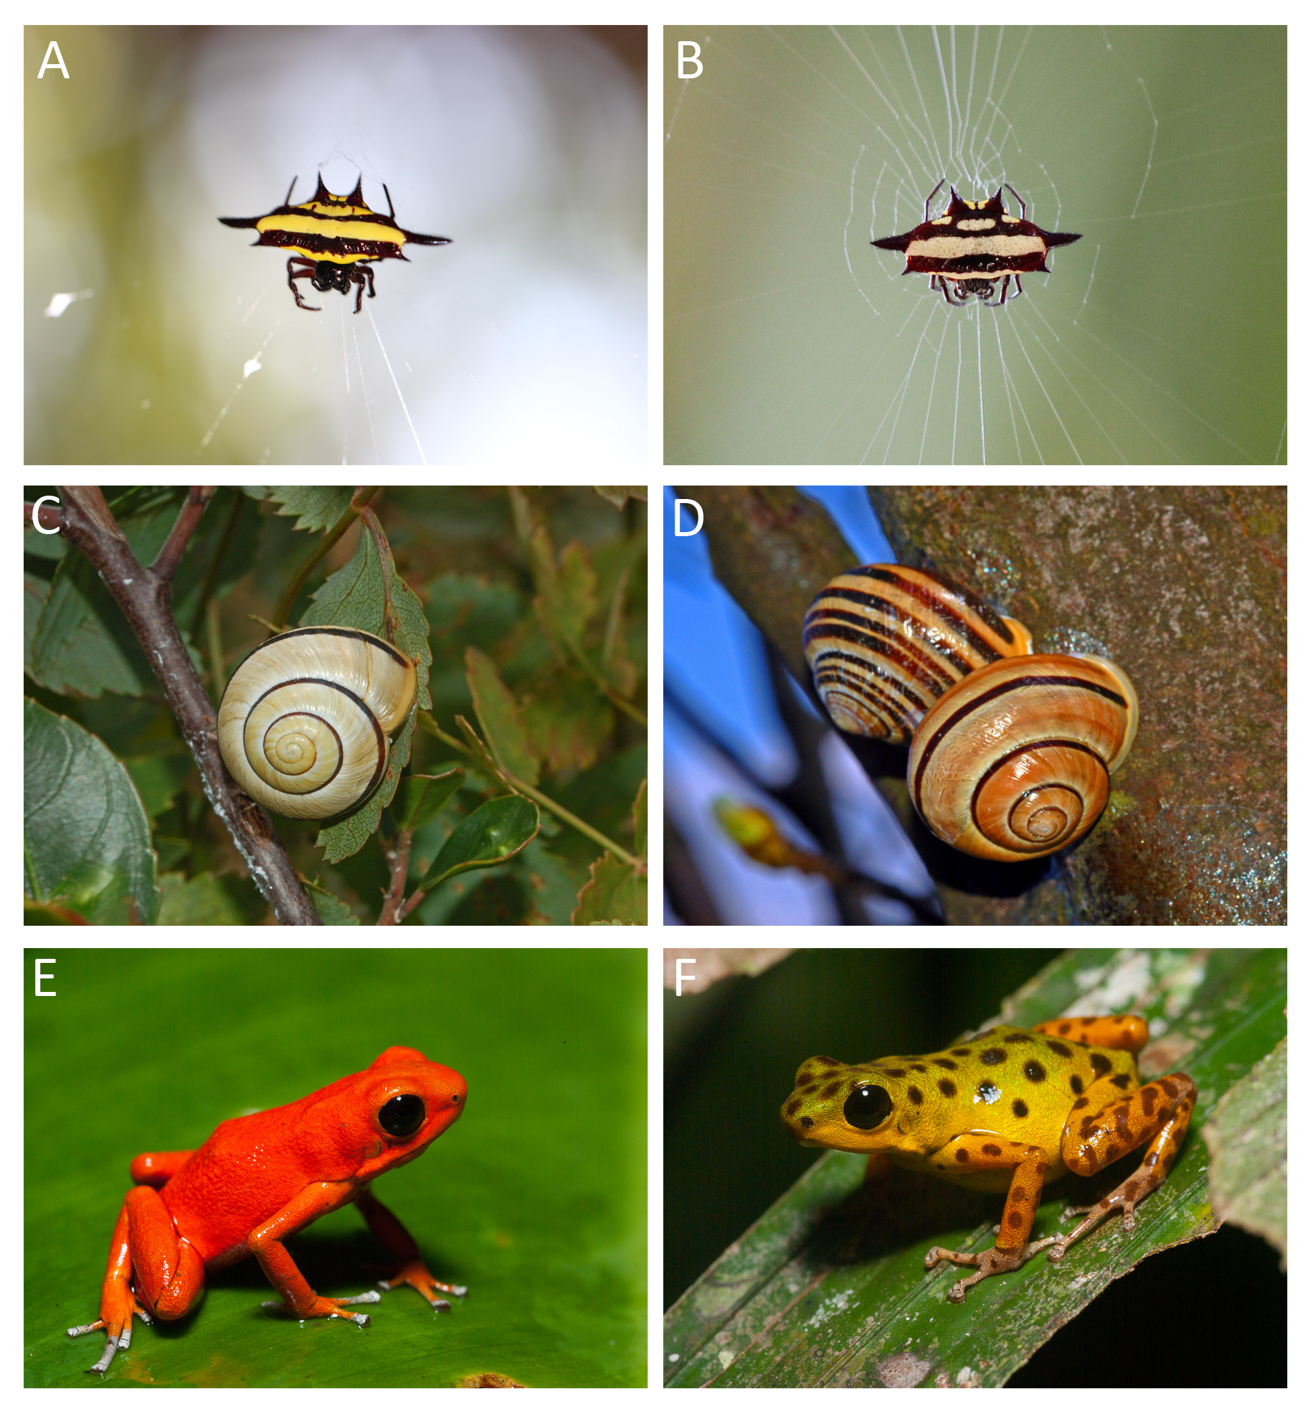

Colour polymorphisms in nature. (a, b) Both morphs of the spiny spider *Gasteracantha fornicata*, whose conspicuous colour patterns visually lure prey (Photos: Thomas White). (c, d) Colour and pattern variation in the highly polymorphic land snail *Cepaea nemoralis* (Photos: Ettore Balocchi). (e, f) Two of 15 morphs of the aposematic poison frog *Dendrobates pumilio* (photos: Justin Lawrence).

# References

1 Bond, A.B. (2007) The evolution of color polymorphism: Crypticity, searching images, and apostatic selection. *Annual Review of Ecology, Evolution, and Systematics* 38, 489–514

2 Gray, S.M. and McKinnon, J.S. (2007) Linking color polymorphism maintenance and speciation. *Trends in Ecology & Evolution* 22, 71–79

3 Wellenreuther, M. *et al.* (2014) Sexual selection and genetic colour polymorphisms in animals. *Molecular Ecology* DOI: <http://doi.org/10.1111/mec.12935>

4 McLean, C.A. and Stuart‐Fox, D. (2014) Geographic variation in animal colour polymorphisms and its role in speciation. *Biological Reviews*

5 Roulin, A. (2004) The evolution, maintenance and adaptive function of genetic colour polymorphism in birds. *Biological Reviews* 79, 815–848

6 Ford, E.B. (1945) Polymorphism. *Biological Reviews* 20, 73–88